Bike Tours Lago Maggiore with the Roadbike

- Round-Tour Lago Maggiore (ca. 185km, 1,800m Altitude, 6.5h)

This tour should be done clock-wise, as you then always cycle on the side of he lake. Take the main street around the lake. At the southern part you need to cross a wooden car bridge to get to the other side. The south-west side from Sesto Calende to Arona is a little industrial. In Verbania take a right and follow the signs to Villa Taranto (nicer street then the main road). At north end near Ascona is a little tricky to find the correct direction. Apart from this very easy to find, as you just cycle along the main route. This tour can be made in one day.

- Half Tour Lago Maggiore/ Mezzo di Lago (ca. 75 km, 305 m. vertical, 2.5 h)
This tour should be done clock-wise, as you then always cycle on the side of he lake. Take the main street around the lake. At the southern part you need to cross a wooden car bridge to get to the other side. The south-west side from Sesto Calende to Arona is a little industrial. In Verbania take a right and follow the signs to Villa Taranto (nicer street then the main road). In Intra you can take the car ferry back to Laveno (runs every 20 min.)

3. Tour di Paso di Cuvignone (ca. 22km, 650m vertical, approx. 1:15h without extension)

Nice short ride with not a lot of traffic. Take the street from Laveno centre to Citiglio. In Citiglio take a left to the Paso Cuvignone. Then it goes continuously up. When you reach the plateau (there is a restaurant on the right) you can turn around.

Extension: Continue until you reach Paso Cuviglione (1036m) - the streets are however not in best condition, buy cycable. You can then go downhill to Porto Valtravaglia and take the lake road back to Laveno.

4. Tour Intra – Baveno – Mottarone - Laveno (approx. 47km, 1,300m. vertical, 2.5 h)

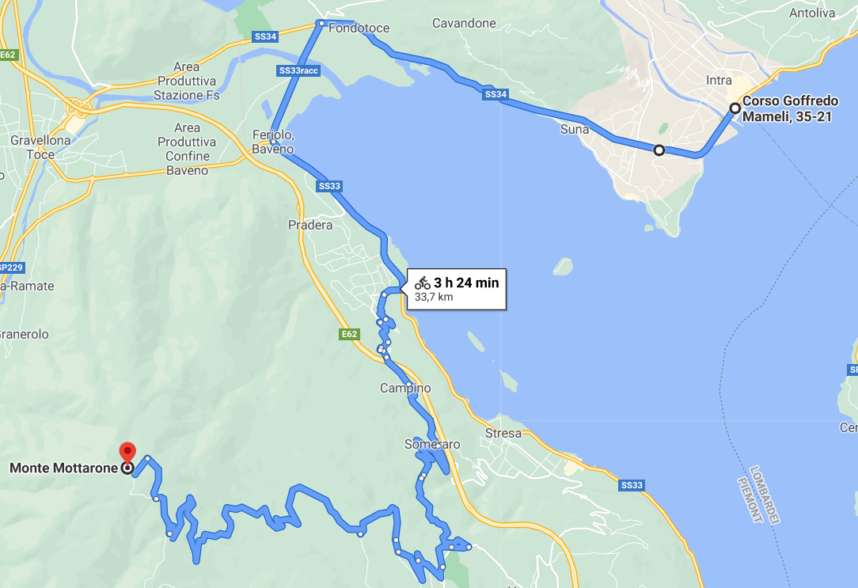 | The Mottarone (1455m) ist he highest mountain in the region and its possible to ski there in winter.  Take the ferry to Intra and cycle the main road to Baveno. In Intra take the road left to Villa Taranto reaching Verbania (much nicer then the main road). In Baveno take a right at Villa Eden into Via Montegrappa leading to Via Marconi up the hill for 21km to the top. Then back to Baveno and Intra taking the ferry to Laveno.

