Directions to our House

Address: Via del Golfo 6,
21014 Laveno Mombello

- Follow the directions to Laveno. In the center of the village near the Lake, there is a round-about. Take the exit to the ferry and train station (first exit coming from Luino along the lake, or second exit coming from Milano/ Cittiglio).
- Follow the road (SP69) over the bridge surpassing the train tracks. You will come to another round-about. Take the second exit (next to Restaurant Lampada) into Via Dalmazia. There are lights where you may have to stop as it is a narrow street. Follow this street taking a right curve. Take a very sharp turn into the next drivable street to the right, which is Via Brianza (not Via Brianzetta in the curve - which you cannot enter).
- Follow Via Brianza up the hill for around 800m, passing Residenza Bassani until the street makes a sharp left turn. In this curve straight ahead is Via del Golfo. Our house is the one on the right with the blue garage. You can either park in front of the garage or in the area of the curve.
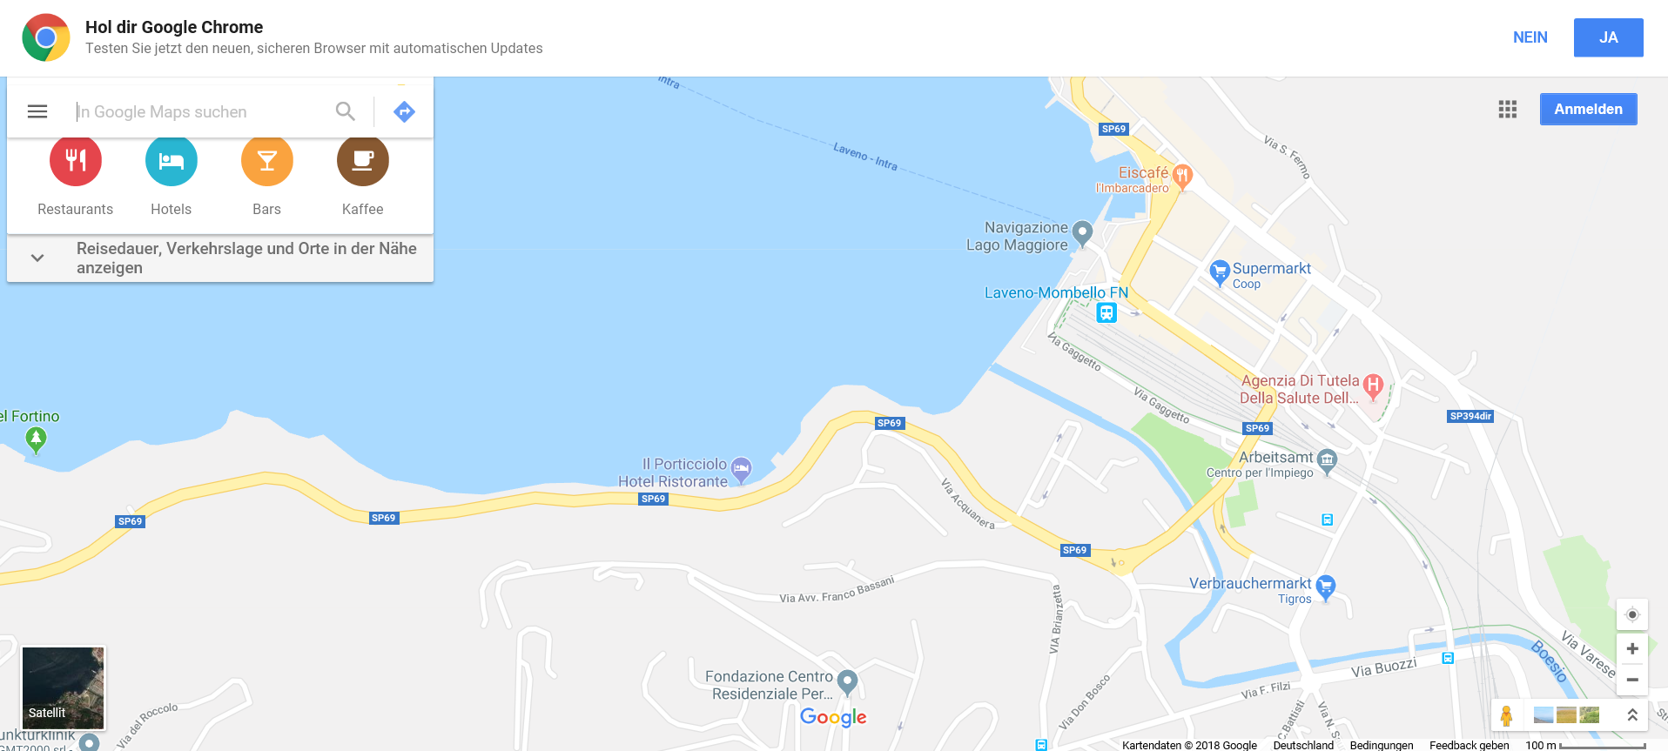
From Cittiglio/ Milano
From Bellinzona/ Luino
Our House
Via del Golfo 6

